URL: <http://www.thomsonmedical.com/>

Carving out a unique identity of providing quality services with a personalized touch in a friendly and cosy ambience, TMC has taken women on the amazing journey of motherhood and embraced the birth of thousands of babies.   
  
With an excellent pool of dedicated doctors and nurses, we have the expertise to care for and support mothers through the joyous yet complex months of pregnancy and childbirth and continue to encourage them by guiding them on how to care for their babies after childbirth.

**Our Vision**  
To be a leading healthcare provider for women and children.  
  
  
**Our Mission**  
We celebrate life with our patients and their families by being an innovator of services that are unique, relevant and integrated, and delivered through our Thomson Touch.  
  
  
Our Brand Promise  
Through our Thomson Touch, we aim to build long-term relationships. We believe in being life partners with our patients and their families.

Services:

**Maternity Services**

|  |  |
| --- | --- |
|  |  |

**Specialised Services**

|  |  |
| --- | --- |
| - | [Thomson Fertility Centre](http://www.thomsonmedical.com/hospital_svc.htm) |
| - | [Diagnostic Imaging Centre](http://www.thomsonmedical.com/diagnostic_ctr.htm) |
| - | [Prenatal Diagnostic Lab](http://www.thomsonmedical.com/prenantal_lab.htm) |
| - | [Thomson Women’s Clinics](http://www.thomsonmedical.com/women_clinic.htm) |
| - | [Thomson Aesthetics Centre](http://www.thomsonmedical.com/aesthetics_ctr.htm) |
| - | [Thomson Chinese Medicine](http://www.thomsonmedical.com/chinese_medicine.htm) |

**Hospital Services**

|  |  |
| --- | --- |
| - | [24-Hour Family Clinic](http://www.thomsonmedical.com/24hrs.htm) |
| - | [Lifestyle Centre](http://www.thomsonmedical.com/lifestyle_ctr.htm) |
| - | [Breast Clinic](http://www.thomsonmedical.com/breast_clinic.htm) |
| - | [Specialist Outpatient Clinic](http://www.thomsonmedical.com/so_clinic.htm) |
| - | [Colposcopy Centre](http://www.thomsonmedical.com/colposcopy_ctr.htm) |
| - | [Retail Pharmacy](http://www.thomsonmedical.com/retail_pharmacy.htm) |
| - | [Rooms](http://www.thomsonmedical.com/rooms.htm) |

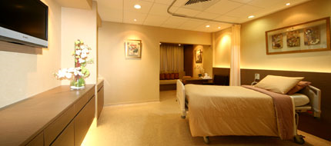 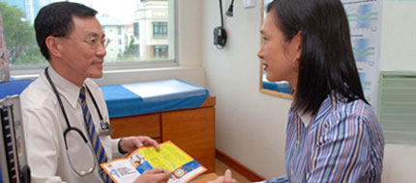 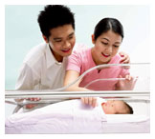

**Doctor credentials:**

Dr Adrian Tan  
MBBS (Singapore) 1984  
MMED - O&G (Singapore) 1990   
  
Dr Caroline Khi   
MBBS (Singapore) 1996   
MRCOG (London) 2000   
  
Dr Joycelyn Wong   
MBBS (Singapore) 1996   
MRCOG (London) 2000

Dr Adelina Wong   
MBBS (Singapore) 1992   
MRCOG (London, UK) 1997   
FAMS 2006

Dr Lim Ah Leng   
MBBS (Singapore) 1972   
MMED - O&G (Singapore) 1977   
MRCOG (London) 1977   
FAMS (Singapore) 1981   
FICS (Singapore) 1981   
FRCOG (London) 1992

Dr Kee Wei Heong   
MBBS (Malaya) 1974   
MMED - O&G (Singapore) 1980  
MRCOG (London) 1980   
FAMS (Singapore) 1984

Dr Ang Poon Liat   
Consultant Paediatrician Special interest in Autism & Nutritional Medicine   
MBBS (Singapore) 1970   
MMED - PAEDS (Singapore) 1973   
MRCP - PAEDS (UK) 1975   
FAMS (Singapore) 1976   
MD (Singapore) 1978

Dr Ang Ai Tin   
Consultant Paediatrician & Neonatologist  
MBBS (Singapore)   
MMED - PAEDS (Singapore)   
FAMS (Singapore) 1991   
Graduate Diploma in Dermatology (Singapore)

**Contact us**

Thomson Medical Centre Limited   
339 Thomson Road  
Singapore 307677   
Telephone: (65) 6250 2222 Fax: (65) 6253 4468   
Email: [contact@tmc-sin.com.sg](mailto:contact@tmc-sin.com.sg)